Computer Programming Using Python 2.7 - **Pygame 3 - Making Sprites Interactive**

GOAL: Edit the previous project to draw another character, and allow player to push the other character.

If you look at the “blit” lines, which draw the pictures, you’ll notice that the background location is calculated from the screen size and car position, so that when you move, the background moves. To add another character, you can use this formula then adjust x and y by the new characters x and y.

* **Open IDLE**
* **File, Open**, H:\pygame\**pygame_Blit.pyw**
* File, Save As, **push.pyw** (in pygame folder)
* Make the Character blank so you can load as many cars as you want:
  + Find the “class Car” line: Under it, there is an “image=” line
  + Select the whole part after “image=” Then do Edit, **Cut**
  + Then change it to image=**None**
  + Go down to where the first car is created: player1=Character()

--under that make a new line, player1.image=

then after the equal sign click Edit, Paste

so that it says something like:

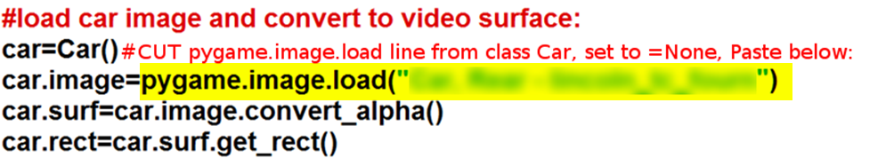

Except the filename should end in dot, extension, unquote, end parenthesis: .jpg") or .png") or other

* Copy & Paste the code under “load car image and convert video surface”

To make another car object with a different name (npc is for **Non-Player Character**):

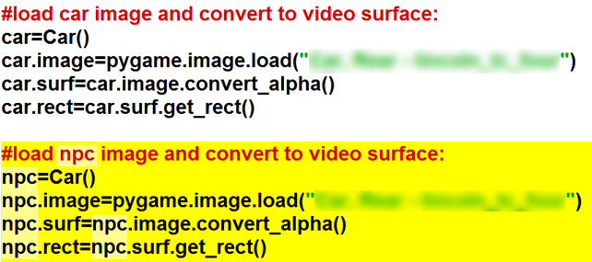

**#then put it somewhere other than where the player’s car is:**

**npc.rect.centerx=200**

**npc.rect.centery=200**

* Now make a **copy** of the screen.blit bg_surf (background surface) line, **paste** on next line, but instead of drawing the background draw the npc and add (+) the location of npc ( **you only have to paste & change second line**—the others should already be there):



* **Run, Run Module**. You should see the other car near you, and you should be able to walk around while it stays in the same place on the map.

Now add code to push the object. You will need to see how close it, is so you’ll need to use geometry (distance formula) which uses squares and square roots. Use **\*\*2** to **square** something, and **sqrt**(something) to get **square root** of something.

* To be able to use **math.sqrt (square root)** for distance formula, add the line **import math** at the top of your code
* To push the object, it will have to be close (within a certain distance), and have to be in the direction you are going. For example, if you are going right, it will need to be greater than the player’s x (on the right of you) for you to be able to push it. Write this code before the blit lines (and indented the same amount as the blit lines):

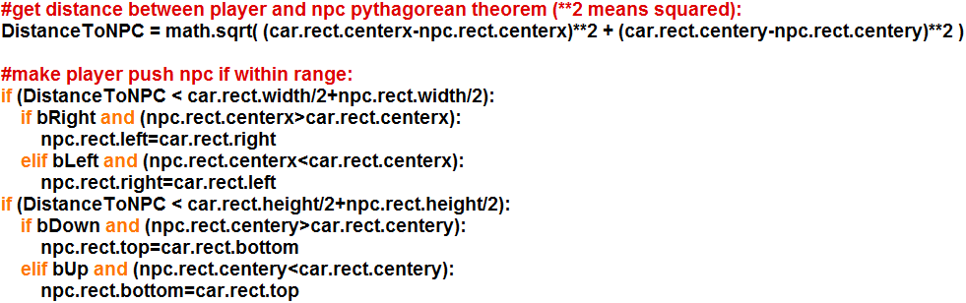

Now Run, and you should be able to push the npc!

BONUS: Try to make pushing corner less jumpy (hint: Setting location changes result of “if” statement next time it runs on the next frame)